To install the SSL certificate manually in Chrome, open ‘chrome://settings’ in your Chrome browser (version 59.0.3071 and above)
Installing on Chromebook (ChromeOS)
- Download the certificate - "nbps-dc01.BASE64.cer"
- On the chrome://settings page scroll down to ‘Advanced’.
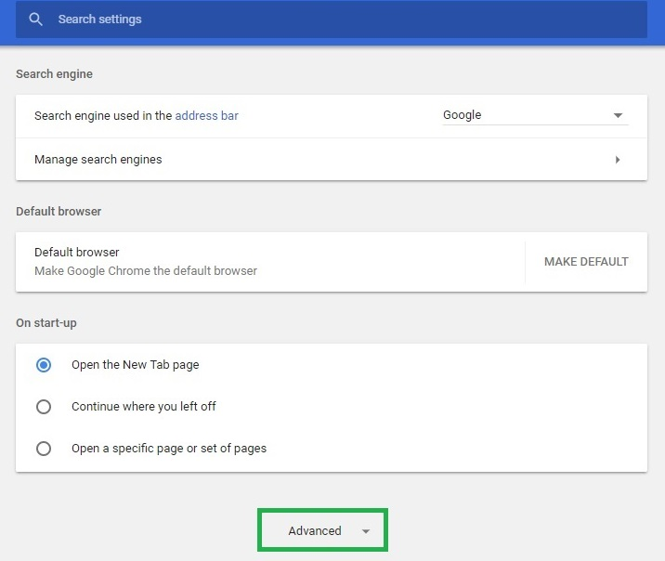
3. Under ‘Privacy and Security’ click ‘Manage Certificates’.
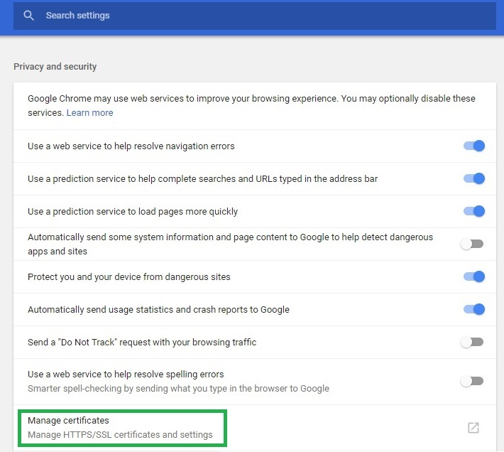
4. On the popup that is launched, select the ‘Trusted Root Certification Authorities’ tab and then click ‘Import’.
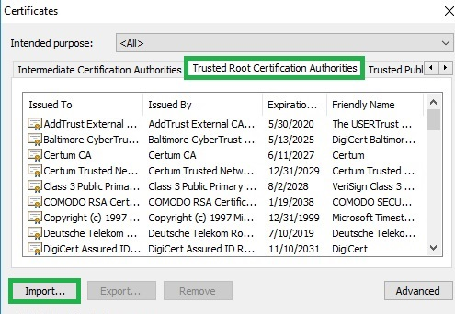
5. A certificate import wizard is launched. Select the " nbps-dc01.BASE64.cer " file downloaded in step 1 and finish the wizard.
6. The installed certificate will be displayed under the ‘Trusted Root Certification Authorities’ tab.
